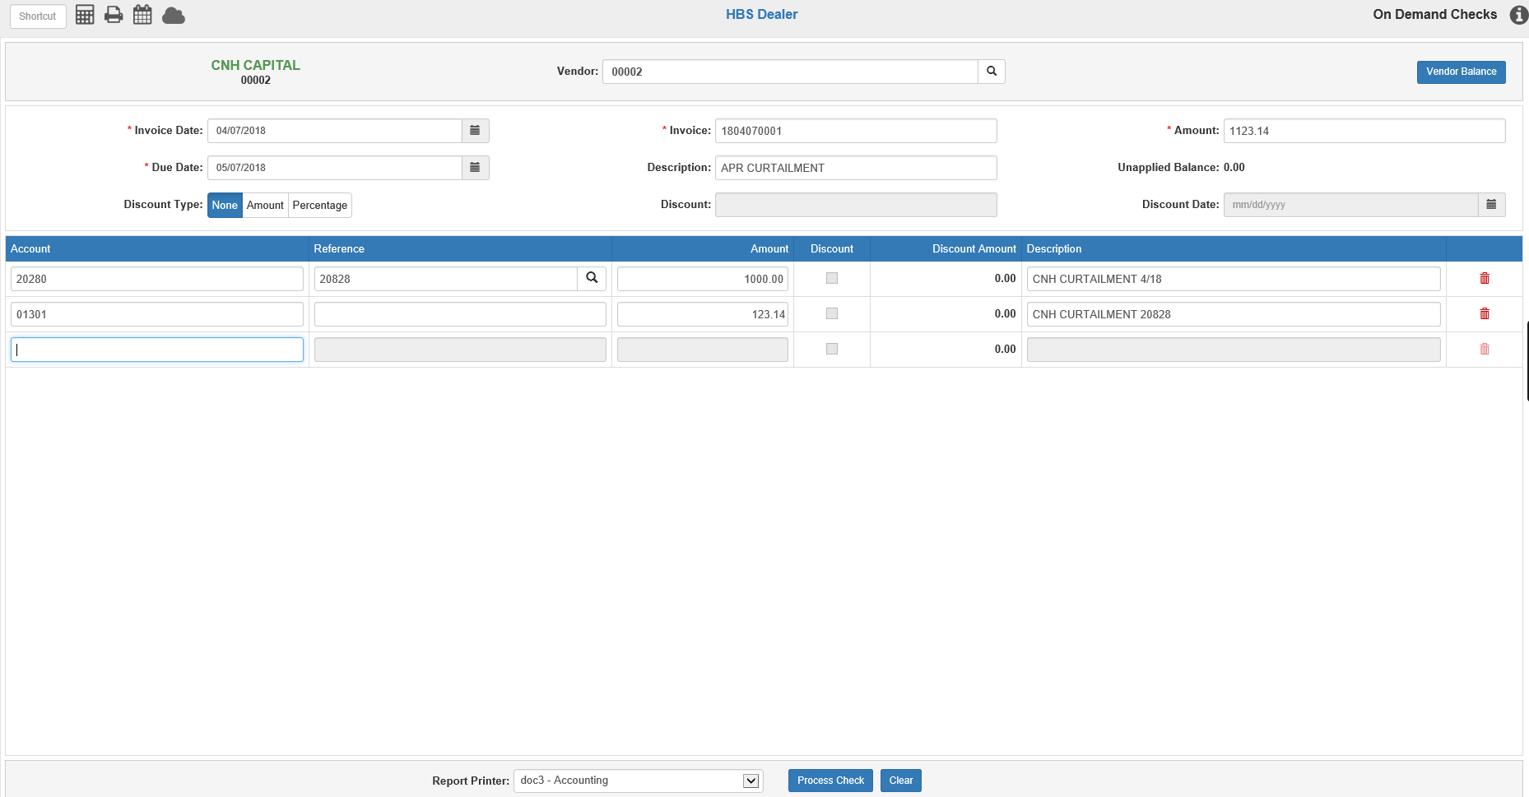
You can use On Demand Checks (ODC) to write a check for a curtailment or for a final payment. You can even process a check for one or more Stock Numbers, and ODC automatically updates the Stock Numbers with the payment information.
Before generating the On Demand Check, gather the following information regarding the curtailment or final equipment payment:
- Stock Number
- Total amount of the check
- Principal (Notes Payable) amount and the interest amount (if any)
- Notes Payable Account Number for the Stock Number(s)
- Floor Plan Interest account
Enter the details of your payment on the account number lines.

Account#
Enter the Notes Payable account number on the lines for the principal payments (20280 in the example above or look it up by partial account number or name). Enter the expense account for floor plan interest on the interest lines (01301 in the example above or look it up by partial account number or name).

Reference
Enter the stock number being paid in this field. The system verifies the Notes Payable account entered for the stock number and will correct it if you have entered the wrong one.

Amount
Enter the amount of note payment or interest expense.

Description
Use a good description to give the details of the payment.
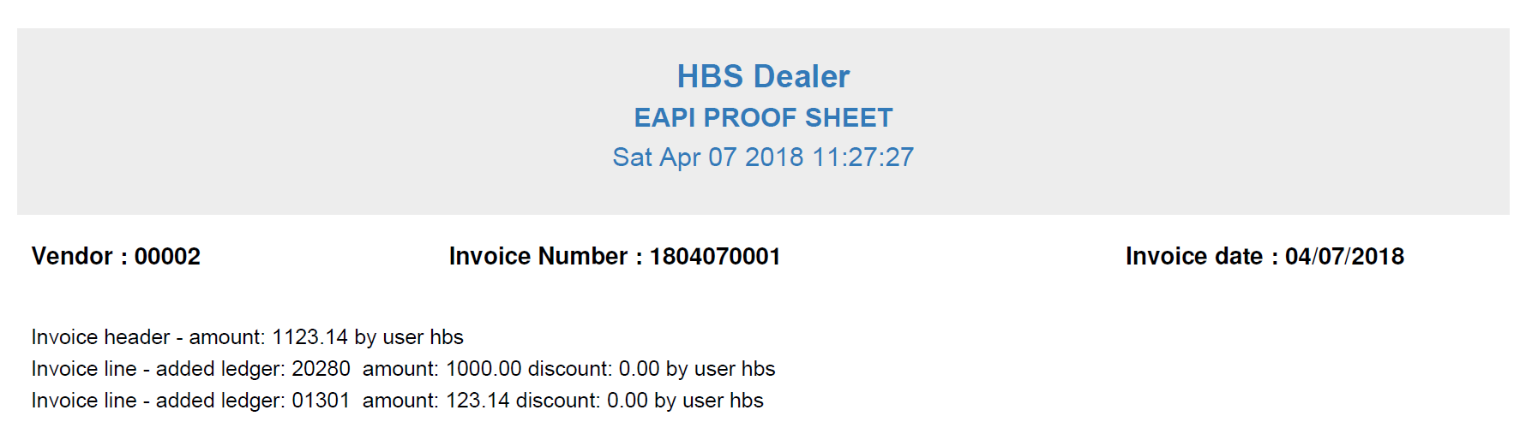
The proof sheet that follows shows the entries made to the notes and interest expense accounts.
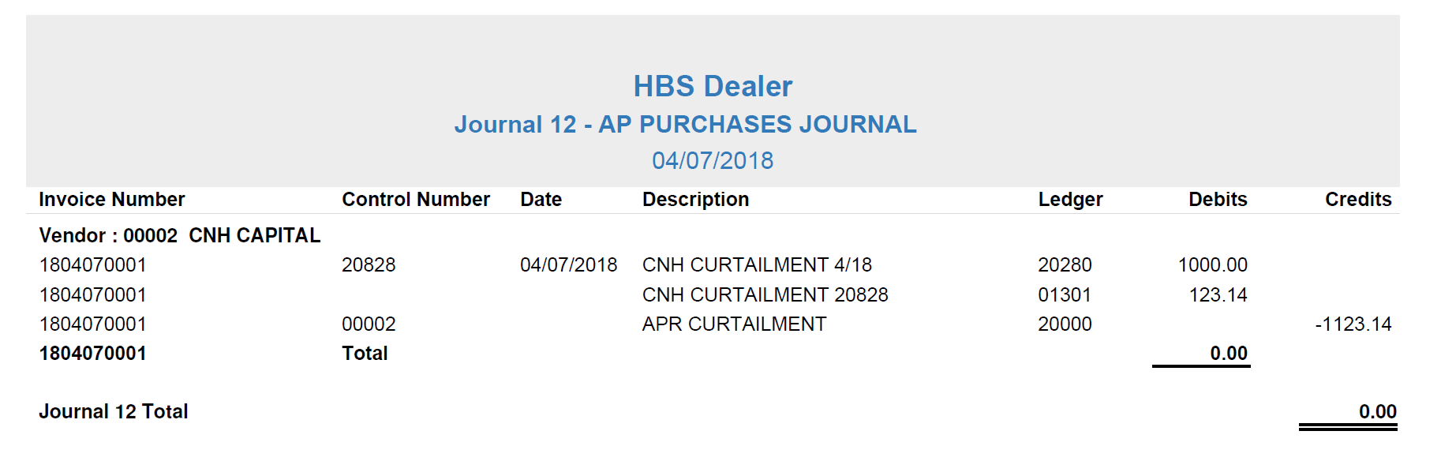
The journal shows the entries being posted to the accounts.
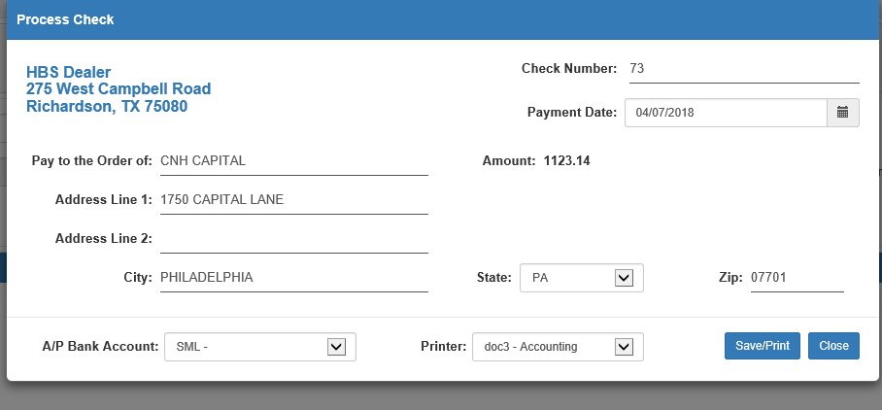
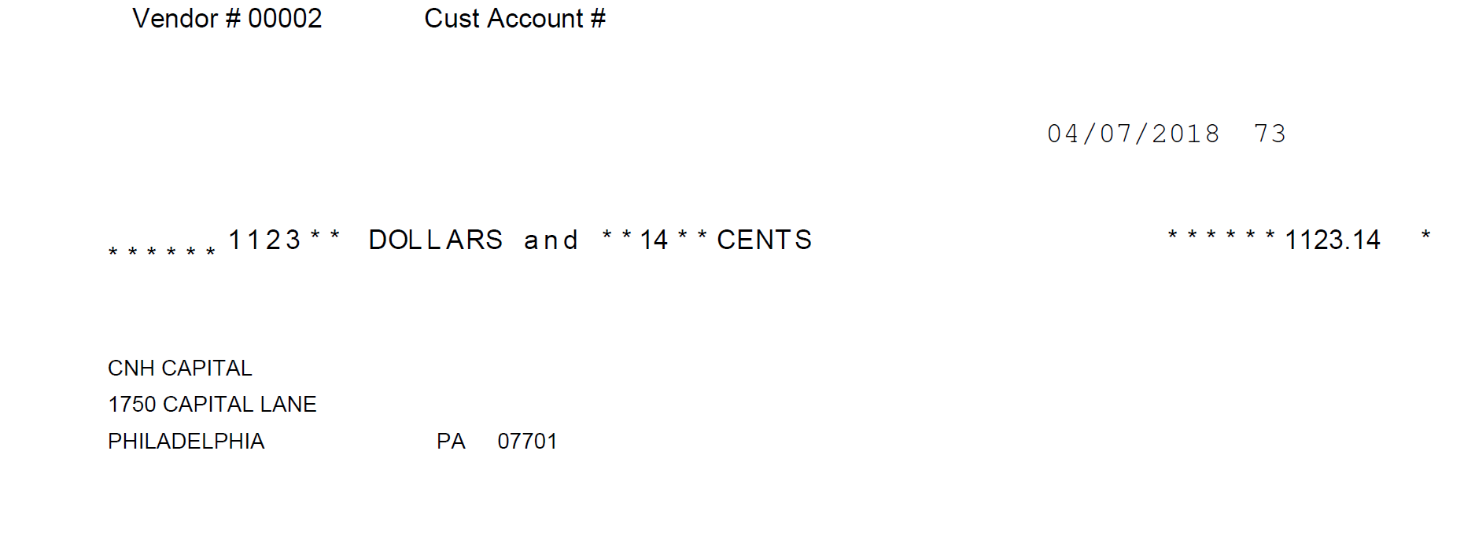
The check is generated to the vendor as entered.
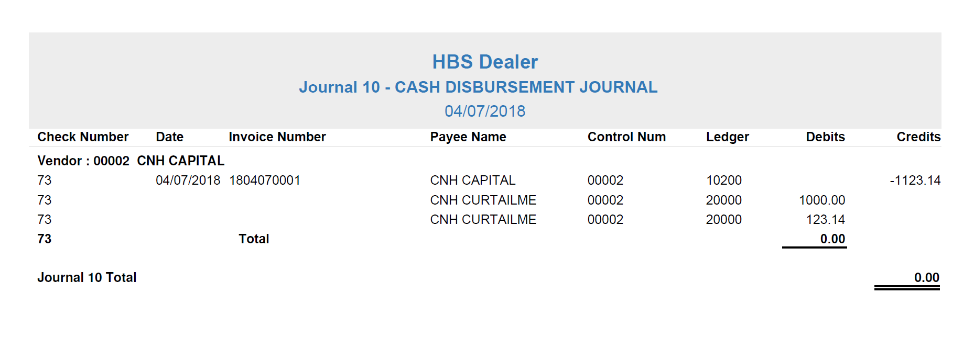
Post the Disbursements Journals (DJ) to record the check.
Here is the Unit Inquiry screen before the curtailment.
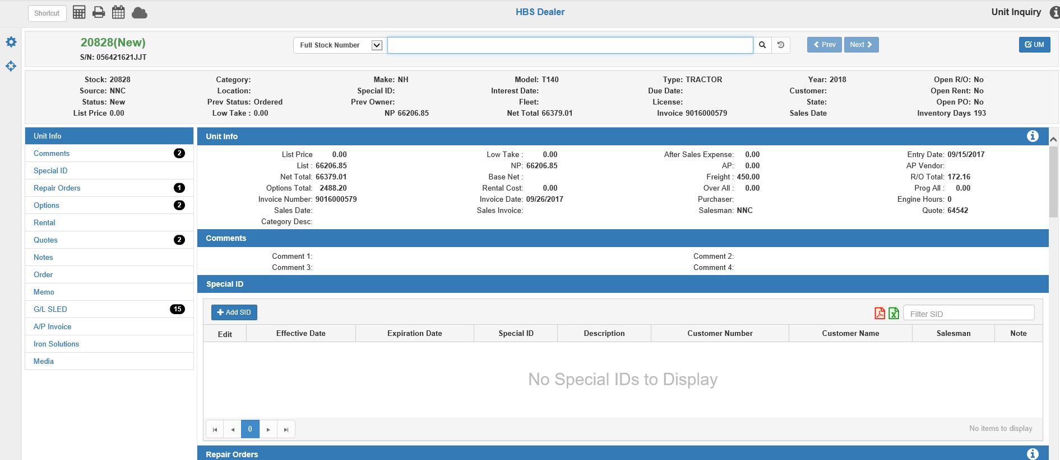

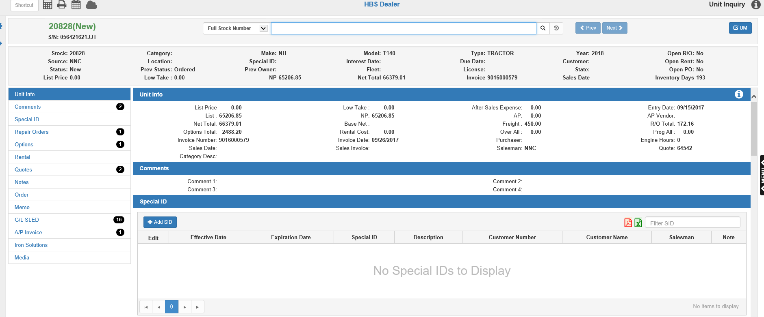
Unit Inquiry now shows the reduced Liability for the unit paid. In this case the original note amount was $66206.85 and now shows $65206.85 after the $1000 payment.
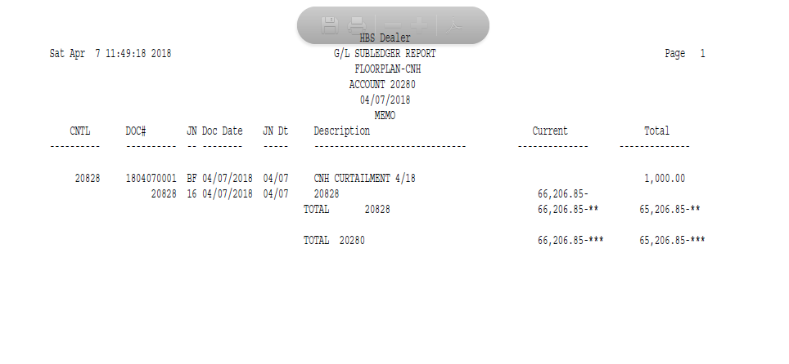
The subledger for the unit shows the curtailment made once the Disbursement Journal has been run.
The previous example showed the process of generating a check for curtailments and payoffs. The process can also be used to create the details of an electronic payment. Using the same steps as described here, however, you can simply print the check on plain paper and the program will still make all the accounting entries to cover the details of the online payment.

Example: Settling for a sold unit with a program discount and a finance contract.
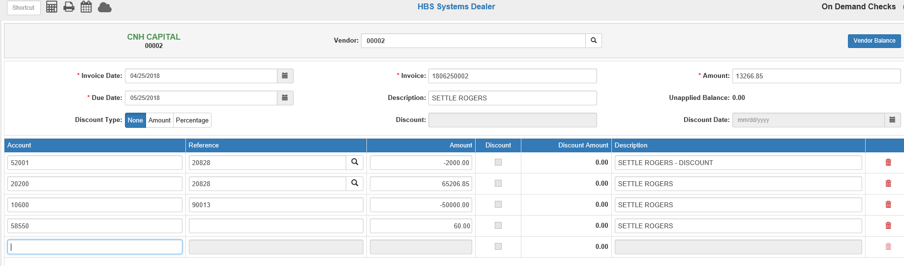
Begin in ODC and fill in the amount of the check due to the vendor. In our example, we begin by take a $2000 program discount. For the discount, we typed in the INVENTORY account number for the unit we sold. Notice how the system AUTOMATICALLY updated the Inventory account with the correct cost of sales account since the unit has been sold. The second line pays off the full amount of the Note on the unit.
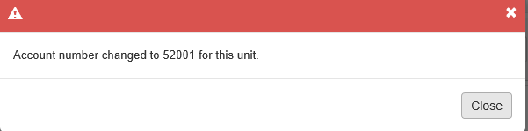
Then clear the Finance Contract amount of $50,000 and record the contract fees of $60.
Post the check with DJ and we can see it has cleared out the details we entered.

Here is the UI screen before we processed the payment and settlement.
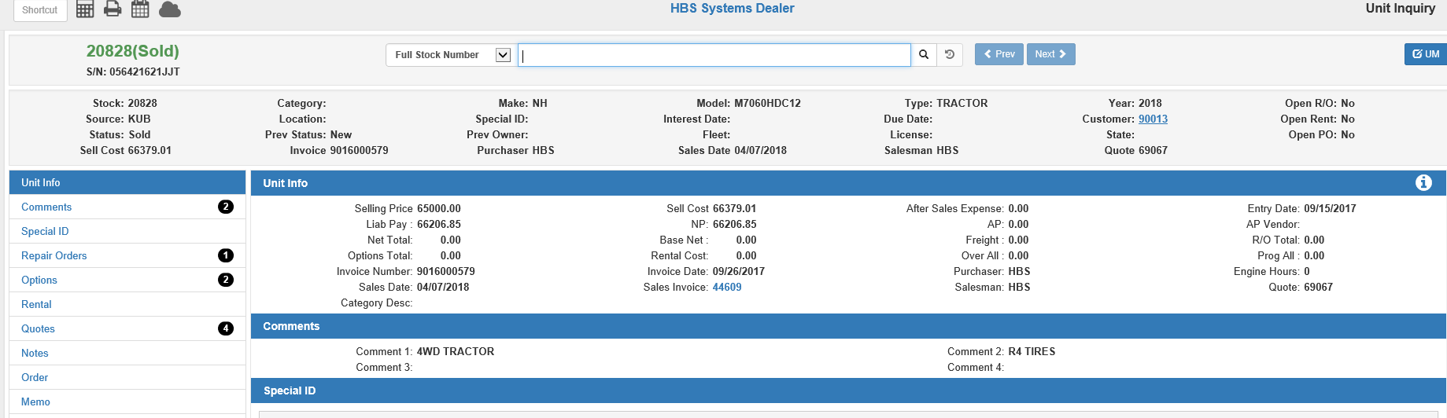
Notice here that the Note amount of $66,206.85 is shown as outstanding. The Sell Cost of $66379.01 is shown as that was the cost at the time the unit was sold.
This is the Unit Inquiry screen after the payment/settlement:
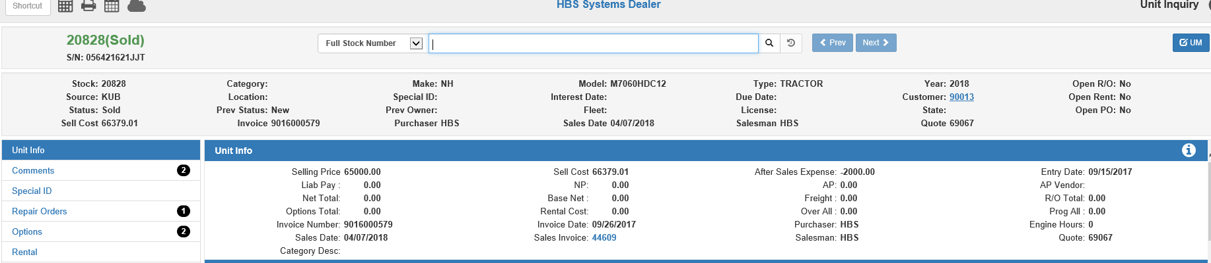

- The Note of $6266,205.85 has been paid off.
- The program discount of $2,000 shows as a credit in After Sales Expense. This shows here because we typed in the INVENTORY account in ODC. That caused the system to associate it with the sold unit and place the amount in After Sales, so we knew this adjustment came in after the sale was processed.
- To calculate the true margin for this unit, you would need to consider both the Sell Cost AND the After Sales Expense amount.

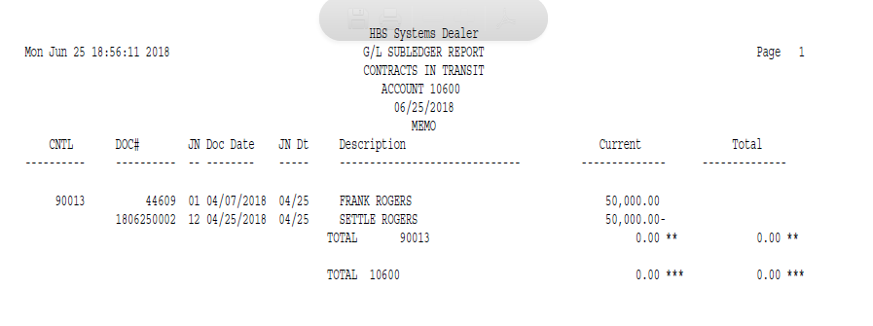
The Finance Contract of $50,000 has been cleared from the Contracts in Transit account too.
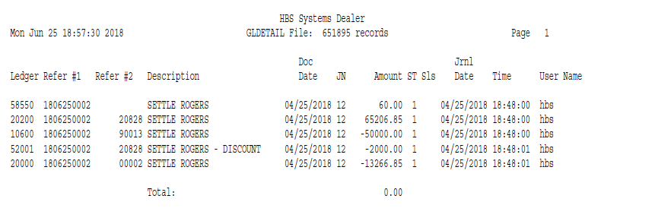
And notice that the Program Discount of $2,000 was credited to the Cost of Sales account since stock # 20828 was sold when we settled for it.

